Project Development Phase
Model Performance Test

Date | 23 February 2026
Team ID | LTVIP2026TMIDS38689
Project Name | Electric Motor Temperature Prediction using Machine Learning
Maximum Marks

Model Performance Testing:
Project team shall fill the following information in model performance testing template.
S.No. | Parameter | Screenshot / Values
 | Data Rendered | The system renders 11 features for manual prediction and 8 features for sensor-based prediction (Ambient, Torque, Coolant, Speed, $u_d, u_q, i_d, i_q$).
 | Data Preprocessing | Implementation of StandardScaler via scaler.pkl to normalize sensor inputs before feeding them into the Random Forest model.
3. | Utilization of Data Filters | Logic implemented in app.py to filter out non-numeric entries and handle null values using try-except blocks to ensure data integrity.
4. | DAX Queries Used | As this is a Python/Flask ML project, DAX is not used. Instead, Pandas/NumPy queries are used for data manipulation and feature selection.  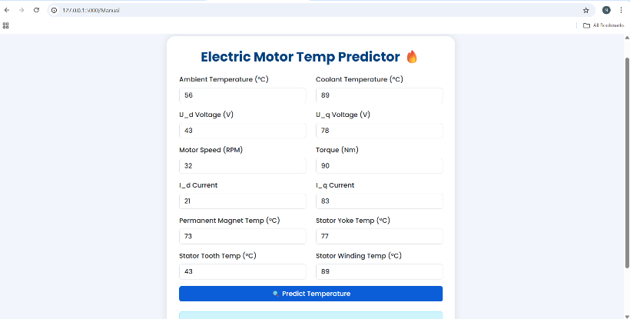
5. | Dashboard design | 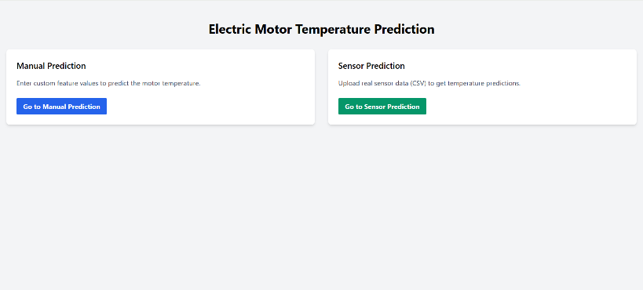
6 | Report Design | 